**ID** – 202003112

**Name** – Pranesh Chowdhury

**1. For A=1, B=2, C=3 calculate 2A+2B-C using assembly language.**

**CODE:**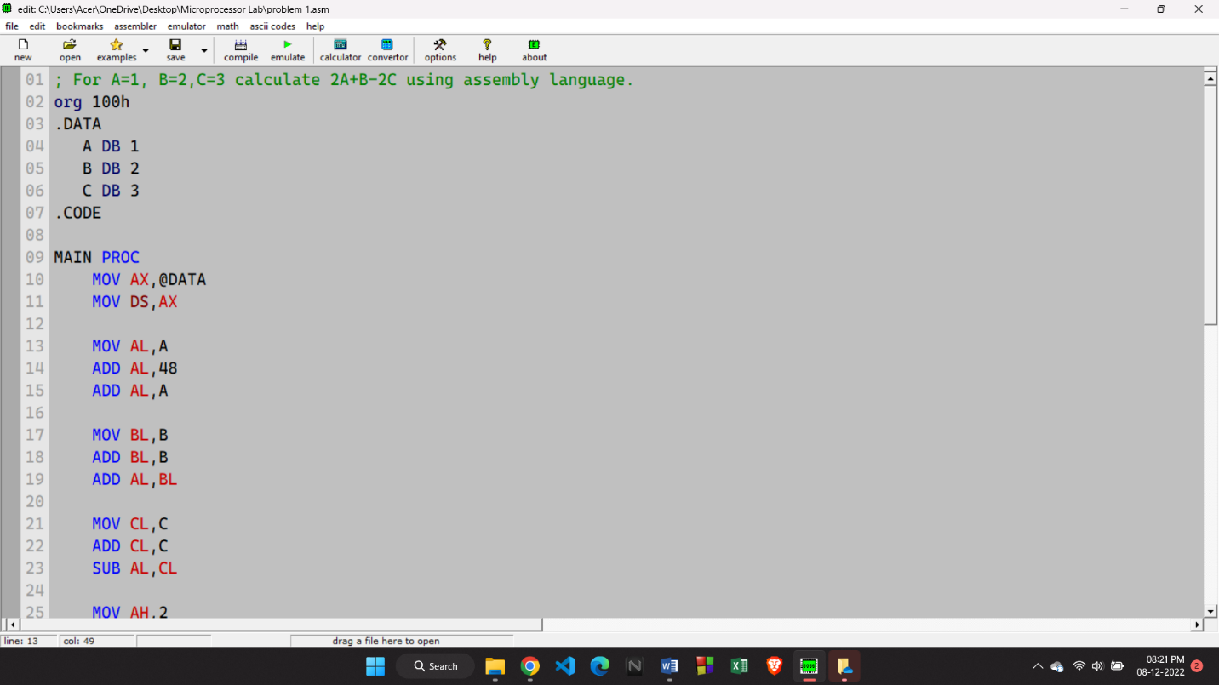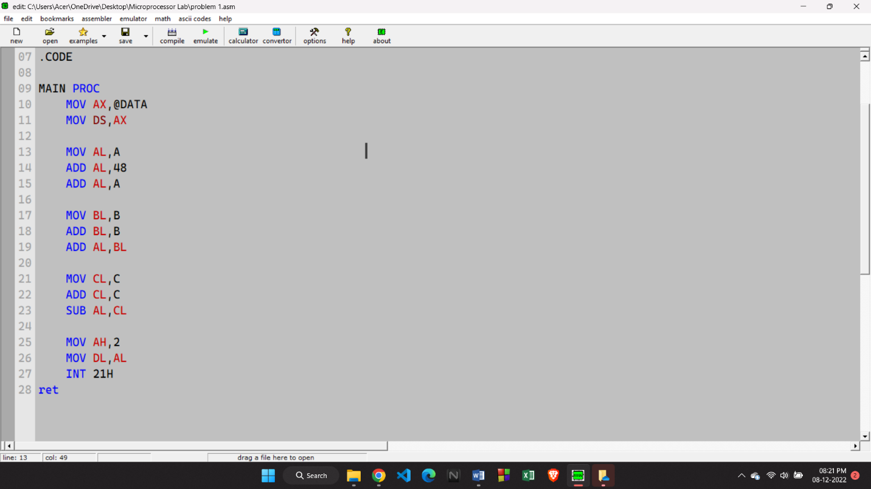

**OUTPUT**

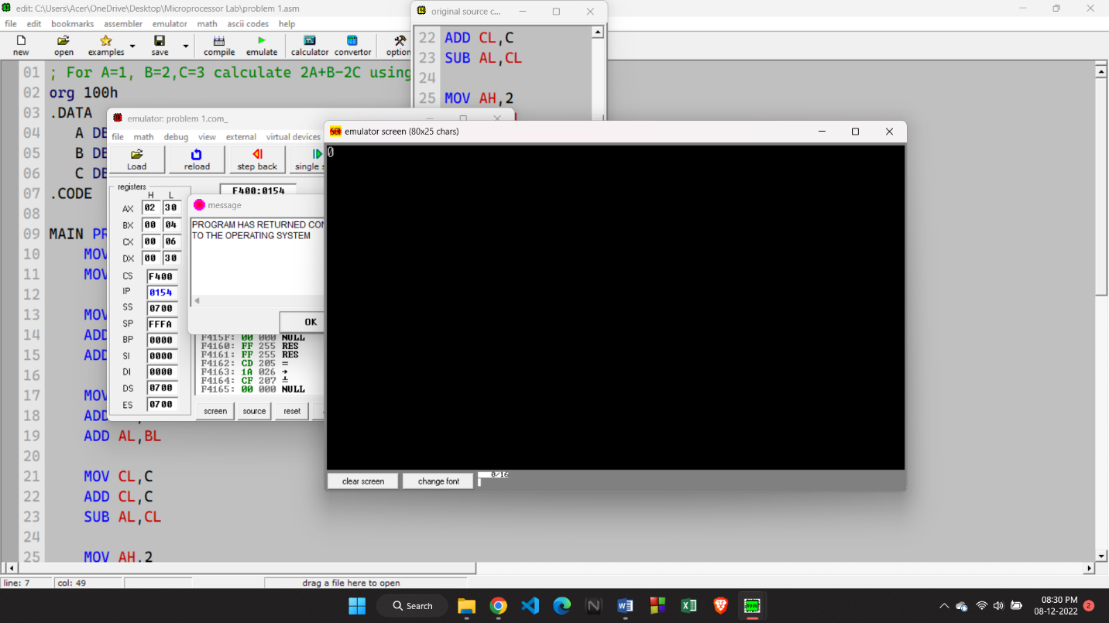

**2. Write an assembly language procedure to swap the values of two registers.**

**CODE:**

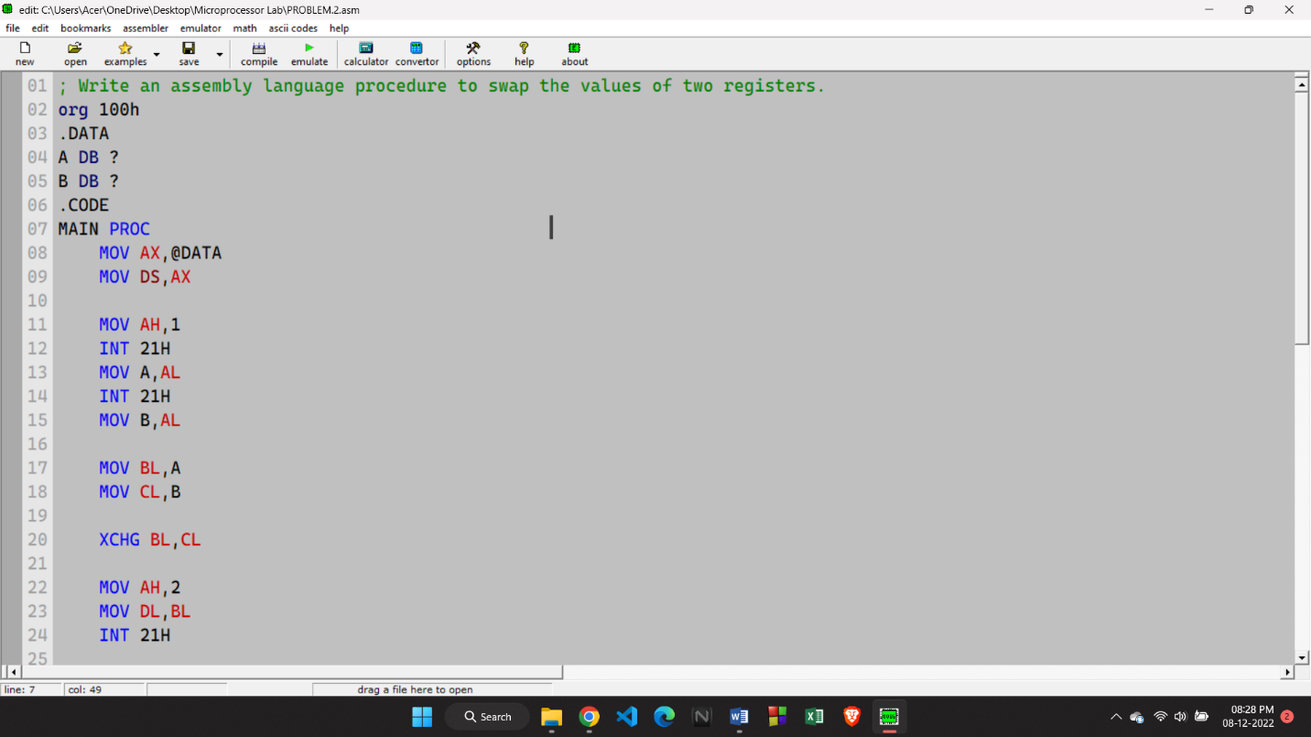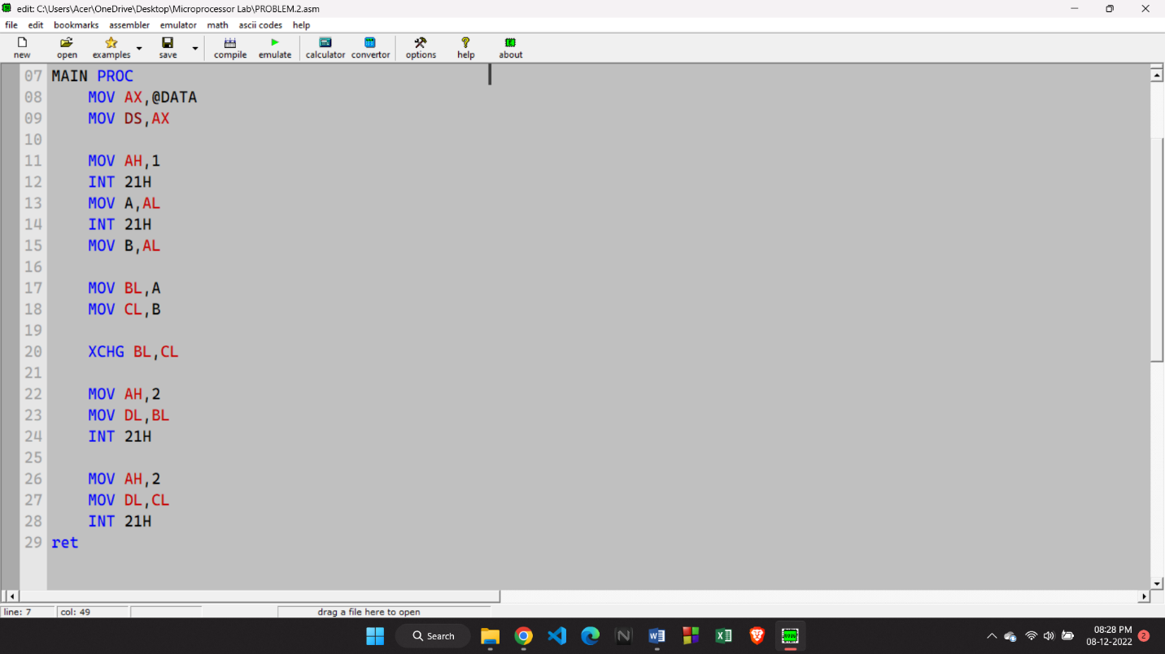

**OUTPUT:**

